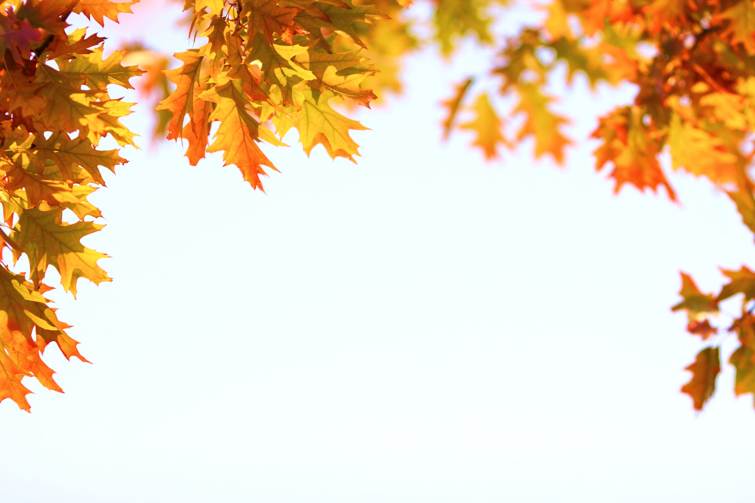
Spooky Halloween Costume Parade

Location: First Baptist Church of Bloomington
Date: October 31st
Time: 4:00 - 4:30pm
Details: As spectators start to arrive around 4pm, cars will be directed to the first parking lot. Then as spectators get settled, we will space out camp chairs and cars in every other parking space to distance everyone before the parade starts. Participants who will walk in the parade will be lined up and distanced before the parade starts at 4:15pm.
Weather Contingency Plan: The parade will be moved indoors to Barker Hall in the event of bad weather. Social distancing will still be maintained with spectators and participants, and parade members will go through one family group at a time.
Social Distancing Requirements: We ask that all spectators and all participants wear masks and keep a six foot space between family groups. This will be maintained whether the event is outdoors or indoors. Spectators are invited to remain in cars if they prefer.
At the end of the parade, each participant will receive a goodie bag, and is welcome to stay in one of the open parking spots to cheer on the rest of the participants.
Following the end of the parade, those who wish to stay are invited to stick around for a brief jack-o-lantern devotional from Pastor Brian.

