On December 3, 2023 the revised Manual on Committees was discussed with the congregation. This new organization reduced the size of the Board and changed the way teams and facilitators communicate their work to the Board and each other. In this year’s annual report, the old names of the committees are being used because the new Board structure has not gone into effect yet. In next year’s annual report, the new names will be used.
As we start using these new names in the coming year, if you are unsure of each group’s responsibilities or how they connect to the Board, please reach out to one of our leaders (who are in the church directory) or to the office. It will take some time for all of us to become comfortable with some of these new names. Our biggest priority and reason for the changes is to encourage more communication between committees and Board members and to free up more time for Ministry teams to spend carrying out their mission.

Table of Contents
Pastor……………………………………………………………………………………………………………………..2-3
Moderator………………………………………………………………………………………………………………..4
Vice Moderator…………………………………………………………………………………..…………………….5
Ministry Leadership and Lines of Communication……………………………………………………..6
Clerk………………………………………………………………………………………………………………...……….7
Treasurer…………………………………………………..……………………………………………………………...8
Statement of Activities…………………………………………………………………………………….9
Statement of Financial Position…………………………………………….……………………….10
Christian Education Committee…………………………………………………………………………..……11
LOGOS…………………………………………………………………………………………………………………12-13
Church Growth ………………………………………….…………………………………........…………………14
Family Care Committee………………………………………………………………………………..…..........14
Missions Committee…………………………………………………………………………………….……..15-16
Nominating Committee…………………………………………………………………………………………….17
Personnel Committee……………………………………………………………………….…………………….. 18
Stewardship Committee……………………………………………………………………………………….....18
Trustees Committee …………………………………………………………………………………………………19
Worship Committee……………………………………………………………………………………………...... 20-21
American Baptist Women’s Ministry………………………………………….……………………………….22
2023-2024 Pastor’s Annual Report
As I look back on this past year of ministry together, there is so much to be thankful for.
In my role as pastor, I get to witness and be part of so many facets of the ministry of the church along with sharing some of the greatest highs and lows we go through in life. It is a profound honor to be present in this journey with you, and to bear witness to the gracious and loving presence of God who calls us ever deeper into what is true and good and eternal.
Some difficult parts of that journey this past year were saying goodbye to so many dear and faithful people, many of whom were long time members of the First Baptist Church family, and some we had just started to get to know. We honor the memory of David Berry, Jo Theobald, Anna Camp, Kay Jackson, David Leben, and Betty PopeJoy, and with gratitude for their lives, entrust them to the care of God, until the time we are reunited in resurrection life through our Lord, Jesus.
And this past year was also one in which we are reminded of new beginnings and commitments, as I was honored to celebrate with Ryan Benton and Annah Lopshire in their wedding in June, Michael Donovan and Melissa Larson in September, and (as an extra bonus) co-officiating at the wedding of Blake Schinzler and Rachel Good (daughter of Jon and Amanda Good) in July.
If the image of what a pastor does is sit in their office and study and pray and write sermons – there is some truth to that, it is some of what I do. But honestly, most of my time is spent in various kinds of communication. Much of it involves meeting directly with our leaders, staff, members about the ministry of the church and how we can care for one another. Another large portion of my time is communicating through emails and phone calls and texts, working through the various opportunities and challenges that are part of the life of the church community. Some time is planning time, listening, and preparing (and again, communicating) for our vision and mission as we move ahead. Much of it is the challenge most of us face at one time or another – always more to do than time to do it in. But it also reminds me how grateful I am for the many, many people who share the ministry and use their gifts and time for the Lord. The church is not about the pastor, it’s about all of us working together, and I’m blessed to be on the journey with you!
A special joy this past year was the opportunity to invite the church and wider community to join in a special campaign called the Debt Jubilee – and I was overwhelmed to see the tremendous response that relieved nearly 3 million dollars in medical debt!
Likewise, thanks to your generosity, we were able to help many people through the Fellowship Fund. Jania Lattimore, our Administrative Assistant, does a fantastic job helping connect people with existing resources, and where there are gaps in what is available, we have often been able to help, providing help with rent, utilities, gasoline (sometimes for people who were living from their car over the winter), work boots, groceries and so on. We have helped both congregation members and people in the wider community. We’ve helped over 14 people this past year with various needs, and your over and above offerings to the church and the fellowship fund makes that possible.
I also work with the region as the Area III representative on the Ministry of Planning and Review and member of the General Board. Specific tasks have included a special project rewriting our regional covenant of agreement to better communicate and reflect what it means for churches that are locally autonomous to be in partnership and commitment with one another for shared mission and ministry. I also serve in our Bloomington/Normal Clergy group in a communication function, as Christian clergy gather for encouragement and cooperative efforts. The Ecumenical Good Friday service is one visible expression of this work, along with our partnership with the McLean County Interfaith Alliance from which the interfaith Thanksgiving service has emerged.

Other things I’ve been a part of this year include helping with the stewardship campaign and developing the narrative budget in coordination with our committees. I was part of the subcommittee on our leadership structure.
In our LOGOS program, I have a lot of fun as a table parent with Helen Ogar at the Sr. High table, and I have helped out with short worship-arts elements in the fall.
I would also like to express my gratitude to the church for your support over the past year after my heart attack, especially for everyone who reached out to Gabrielle and checked in on her. That means the world to us. Life is more precarious than we sometimes realize, but God remains steadfast, and through all the changes, God is good.
And that’s something worth holding onto as we look ahead into the coming year. As we look at what it means to live out our faith in a world full of changes and uncertainty, it can bring out a lot of different feelings – sometimes excitement, and often fear and uncertainty, even grief and anger. There are parts of church life that look a lot different than in the 50’s, or the 80’s – or even just twenty years ago. If we look at the big history of the church, that is a reality going all the way back. It always changes. There are different challenges and controversies – but the same God and the same Holy Spirit who is always nudging us out to reach our community, and who is drawing us back together to the center to stay connected with Christ and one another.
So may we indeed be bold and courageous and full of the love of Christ as we move into this new year, seeking to let the Holy Spirit direct us in all the different ways we will be living out our faith together.
Blessings on the Journey
-Pastor Brian

2023-2024 Annual Moderator Report
I am pleased to have been a part of the work of the First Baptist Church this year. There have been several Ad-Hoc committees formed to update the constitution, restructure the Board, and study the most effective ways to finance various aspects of the church, ranging from missions to maintaining the building. These projects are in addition to all the work the committees have been doing to support our members, the community, and missionaries around the world.
Members of our church have also been collaborating with members of other houses of worship on several projects. One example of this was raising funds for the Medical Debt Jubilee. Our church was able to join with several other churches in the community to pay down the medical debt of many people in the area. Other examples of collaboration include the Thanksgiving and Good Friday services.
The Board has appointed Becky Strack as our Church Archivist. Having Becky in this position will facilitate the retrieval of items with historical significance from our previous church buildings. Becky has also been instrumental in helping the Ad-Hoc committees research topics such as accounting policies and procedures and Board structures over the years.
The Board is also planning for several large expenses that are necessary to maintain our 30-year-old building. An Ad-Hoc committee was appointed to develop an efficient plan to secure the funds needed to adequately maintain our physical plant. Our goal is to discover ways to diversify our investments to meet all of our financial needs. You will hear more about the work of this group in the future.
The Church Leadership continues to provide opportunities for church attendees to be involved in meaningful ways that help each person’s faith grow while building relationships with others. We are supporting two worship services, a mid-week program for youth and adults, small groups, and a variety of committees.
If you are interested in exploring ways to get more involved in our church activities, talk to the Pastor or any Board member and they will help find opportunities that match your particular interests and skills.
I would like to thank everyone who has volunteered their time and talents as Board members, committee members, LOGOS workers, praise team members, and tech support, who, along with our wonderful church staff, have worked tirelessly to move the mission of the church forward. This year, I hope we can experience personal growth and growth as a church community as we continue to reach out to serve the needs of the community around us. As you read the committee reports, you will see that the members of our church are committed to finding creative ways to make First Baptist Church a living example of the work of Christ in our congregation, local community, and worldwide. You are all a vital part of this work, and I hope we can all find new and exciting ways to serve.
As Moderator, I have enjoyed working alongside and becoming better acquainted with members of the Church Board as well as members of the congregation, and I am honored to be able to represent the congregation at the board meetings. Please know that if you ever have a question, concern, or suggestion, I would be happy to present your concerns or ideas to the Board at the monthly meetings. Please take the time to thank the people who are completing their current term on the Board as well as those who will be joining the Board this year. Also, please consider being a part of a committee that interests you and possibly collaborating with people with whom you do not usually cross paths. Committee work is a great way to get to know members of the congregation and experience personal growth.
Respectfully Submitted
Mary Jo Douglass Moderator
2023 – 2024 Vice Moderator Annual Report
It was a privilege to serve the congregation as Vice Moderator for the past few years. One of my objectives as was to assist the Pastor and Moderator by leading special efforts the Board determined were priorities, in addition to chairing the Nominating Committee. A separate annual report from the Nominating Committee has been submitted by me this year.
Some of the major projects have included updates to the Constitution, Leadership/Structure revisions, and Digital and Physical Presence updates. Both the Constitution and Leadership/Structure ad-hoc committees have completed their work and have been approved and affirmed by the congregation and Church Board. The Digital and Physical Presence committee continues to meet loosely via email. Several small changes have been made to the FBC website and an outline of the next steps has been discussed. Though we have not made as much progress as hoped, we are determined to see this work through in the next several months.
Some of the other efforts that I have been part of include supporting the Stewardship Chair, moderating the committee selection meeting, giving a small presentation at the annual Board retreat, and monthly agenda planning with the Moderator and Pastor.
The Church continues to have strong leadership which is greatly appreciated. I encourage everyone to determine individually how they can support the Church by participating in Church life in some manner. Together we will continue to achieve meaningful outcomes, thank you.
Respectfully submitted,
Al Strauch, Vice Moderator

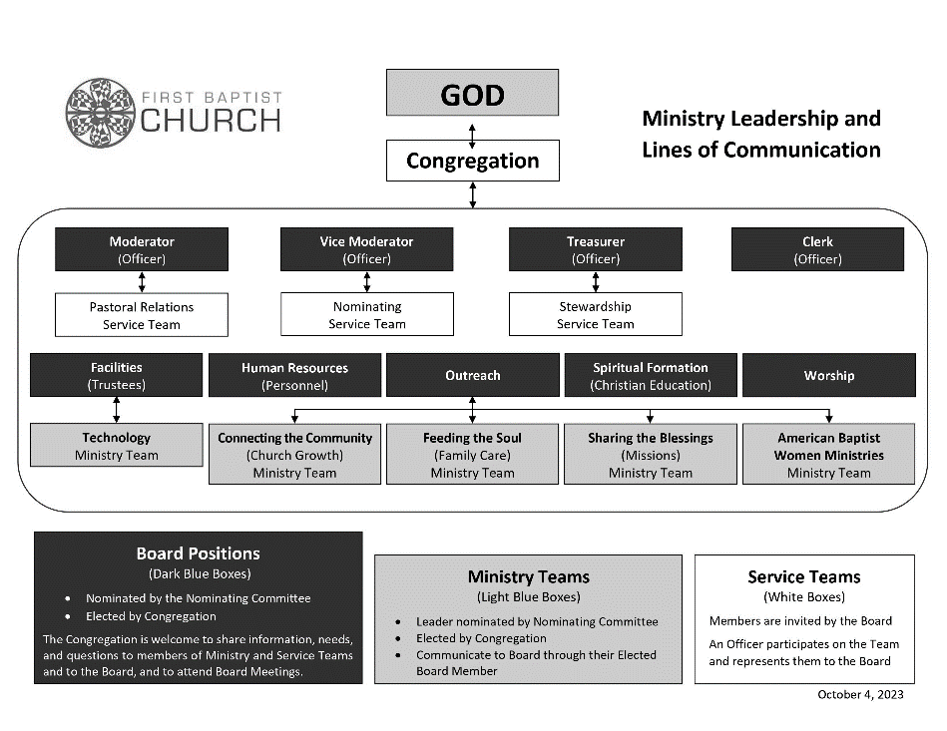
2023-2024 Clerk Annual Report
Using Simple Church computer records we are listing our membership as Active Members and Active Non-members and adding these two together for a total of Active Participants.

Additions

Statement of Faith…………………………………….……………………………..…………………...0
Transfer of Letter…………………………………………………..……………………………….………1
Tom Otto (2/4/24)
Baptism…………………………………………………………………………………………..….…..….....0
Total..…………..…….….1
Losses
Death…………………………………………………………………………………..……………..….….…6
Members
David Berry (June 30, 2023)
Josephine Theobald (July 31, 2023)
Kay Jackson (October 19, 2023)
Anna Camp (October 20, 2023)
David Leben (November 1, 2023)
Betty Popejoy (January 13, 2024)
Total………………….…...6
Membership April 2024
Active Members………………………………………………………………………….…………………….…..128
Active Non-members……………………………………………………………………….………………...….125
Total Active Participants 253

Joyce Topping, Church Clerk

2023 Treasurer's Annual Report
The operative word for calendar year 2023 was generous 😊. Our church finances experienced a very generous year, thanks to continued faithful giving by our congregation. (Note: Unlike the church Committee Reports, the Treasurer’s Annual Report is based on the calendar year, as that is our church fiscal year.)
Attached to this narrative are two reports which offer a look at our overall financial health as of December 31, 2023.
The first report -- titled Statement of Activities -- summarizes our Actual Total Income and Total Expense for 2023. This report also compares our actual income/expense to our budget for the year. The following summarizes the Statement of Activities for 2023 (year-to-date actual column):
- Total Income: $395,403.08
- Total Expense: $343,255.50
- Surplus: $52,147.58
The second report -- titled Statement of Financial Position -- shows our year-end assets and liabilities as of year-end 2023. This report is summarized as follows (year-to-date balance column):
- Checking Account Balance: $155,963.33
- Investments in Baird: $540,177.03
- Investments in CDs: $70,000.00
- Total Assets: $766,140.36
- Total Liabilities: $0.00
- Total Net Assets: $766,140.36
One additional note (repeated from last year’s report): Hilliard Lyons Trust, which proficiently managed our investment account, rebranded to Baird Trust in September 2021. This change has been seamless to us, and we are continuing to receive the same good service from Baird. For more information on Baird Trust, please see rwbaird.com.
As always, the Treasurer offers many thanks to our Financial Secretary for her accurate and timely reports.
Respectfully submitted,
Glen Wetzel, Treasurer

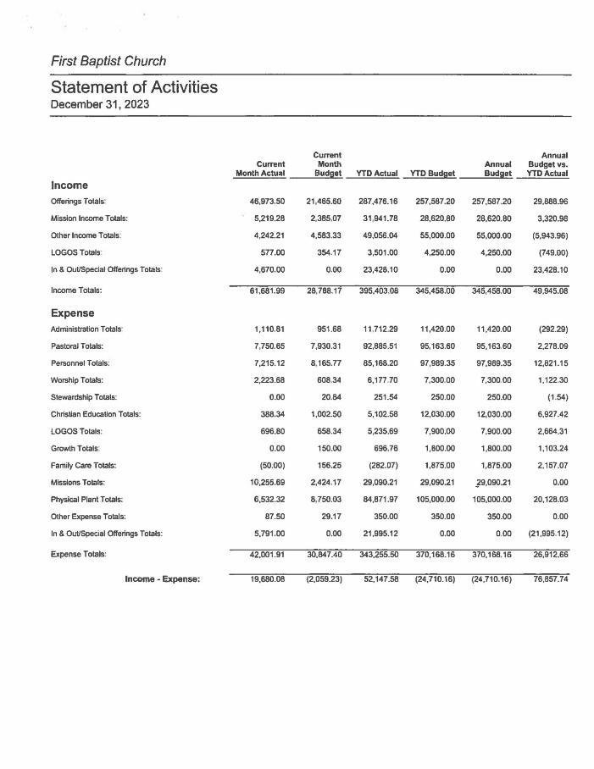

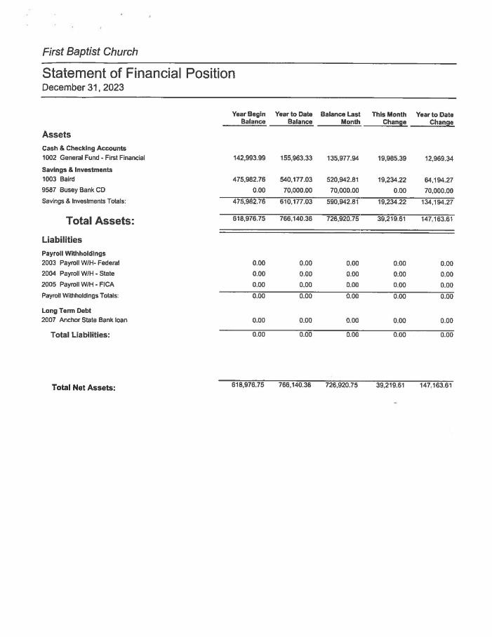
2023-2024 Christian Education Annual Report
Committee Members – Nathan Jennings; Chair, Glen Harms, Lisa Strack, Michelle Wiggins,
Purpose: Alongside and in partnership with the paid church staff, promotes and implements educational programming, leadership, and fellowship ministries
The 2023 Christian Education year started strong with an impressive turnout and fundraising effort for our youth at our Annual Souper Bowl Sunday, almost $1800 was raised. The Sr High youth were invited to attend the Gen-On Trip to Wheeling, WV. Only 1 youth member made the trip. Working with Gen-on again for a similar trip in 2024.
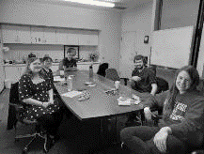
2023 continued on with a fair offering of Small Groups for Adults – long time Sunday school classes are held typically after Morning Worship on Sundays. Youth and Children still do not meet as a small group before or after Church on Sundays. There has not been much demand/request for that option as the youth/children have extensive activities on Wednesday with the Logos program. Children continue to have the option to join in Childrens Church during the 2nd half of the regular worship service. This small group has a variety of children that have taken part in activities. The CE committee is always happy to listen to suggestions and will continue to review the interest and demand for additional programming.
FBC Small Group- Young Adult JAZZ Group
Small Groups continued to thrive in a variety of settings both on church grounds and outside of the church property. With the help of Michelle Wiggins and volunteers, numerous activities were held throughout the year and during the summer.
Vacation Bible school was held in August, and we had a nice selection of our children/youth and additional members of the community each evening in addition many youth and adult leaders that came throughout the week. We are looking forward to continuing the VBS tradition, but official plans have yet to be determined.
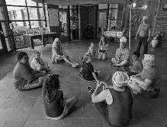
We had 5 youth decide to participate at Lake Springfield Baptist Camp over the Summer of 2023 and we hope to send another large group throughout this upcoming summer. LSBC offers a variety of camps that can fit the interests of our students/youth. LSBC is also typically looking for additional help with staffing for individual camps or work projects. Please feel free to contact the Camp Manager at LSBC with any questions. For the 2024 year, we are hoping to add additional campers and staffing to attend Blackhawk Baptist Camp in Oregon, IL.
Vacation Bible School group session
Considering the continuing changes and needs of our congregation, CE remains dedicated to providing Christian Education opportunities. We are always looking for new ideas and partners to work with and for the future of our Church.
Nathan Jennings – Christian Education Chair

2023-2024 LOGOS Annual Report
Committee Members – Michelle Wiggins; Chair, Melissa Donovan, Chrissy Jennings,
Jania Lattimore, Alan Markwood
The LOGOS CARE team prioritized our top goal this year as giving the youth tools and resources for them to continue their faith journeys. We wanted to focus on getting to why we do things and their deeper meanings. LOGOS is an intergenerational program, but we made an emphasis to include ALL the generations.
Worship Skills included skills that were examples of corporate and personal worship. There was a choir unit and chimes unit that shared their skill in both the Vespers and Sunday Morning Worship Services. The LEGO units this year took apart and illustrated the stories of the birth of Jesus and the crucifixion. Newer skills done this year included creating devotional videos to share on Gratitude and a unit on Meditation, Prayer, and Nature. The Vespers Service allowed many of our youth to try out their own worship leadership. Each week, there was a group that chose whether they would be a part of Worship Skills Unit or a part of the Tech Team in Vespers. We also had a Vespers Service this year where the youth learned how to plan a service. They led the entire service including the music and devotional time.
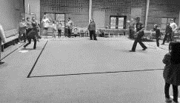
LOGOS Bible Study wanted to make sure youth were getting into deeper discussions in class. This year we divided the Junior High Students and the High School Students into two different classes. The Bible Study Time for Junior and Senior High was no longer during the Vespers Service, so all youth were able to attend class. Lil LOGOS continued with the preschool LOGOS curriculum while Elementary went with Cokesbury’s Celebrate Wonder. That curriculum was specifically geared for a class that would be at developmentally different levels with it being for 1st to 5th grade. It also included Wonder Cubes which were dice that had questions for further discussion and understanding. The leadership created Cubes for the High School and Junior High Class to go along with their curriculum of Intersection. These cubes were intended to teach comprehensive questions that help analyze Bible stories.
Baseball Night: Family Time activity
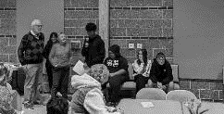
Recreation came up with many activities to encourage fellowship and community among the students. This was a challenge as many of our youth would say their preference is for individual activity. Board games were very popular this year. We had international board games, oversized games, and homemade games. Recreation also had many messy crafts nights. One such craft day had the youth creating Christmas Ornaments donated by Beverly Berry from David Berry to make decorations for the Upstairs CE hallway for Advent.
Family Time was also filled with fun activities to encourage our youth on ways to live their lives for Christ. This year had Lisa Strack teach CPR and safety to the youth. Dinner Dean Becca Hall had First Responders from different stations across our community visit. This was the first year that we allowed our High School Students to sign up to be a member of a cook team for their Worship Skill time.
LOGOS T-shirts were created in Family Time using fabric spray paint and Encouragement Rocks were created to share with others.
Presenting at LOGOS
During Family Time, we also practiced uplifting others by sending out Care cards to those in our congregation that were having surgeries, grieving or we missed. This is also the first year with Happy Fun Bags where people could share cheerful messages. These bags were taken home on the last LOGOS night.
LOGOS shared God’s love through different Mission projects. College Care Packages were filled and sent out to our FBC college Students. With collaboration from ABWM, final exam gift bags were made for all the AGAPE students. Our Junior High and High School students went shopping together for gifts for the Share N’ Care. Andrew Rains, the Camp Manager of LSBC, came to talk and we took up a special offering for the ministry there. During Holy Week, there was a LOGOS Mission Trip to spread Easter joy and visit those of our church family who are unable to attend church in person.
One of the main challenges of this year’s LOGOS was obtaining personnel. To help aid our youth, we needed higher leader numbers for more individualized attention and discussion. This year also needed a lot of substitutes from leaders not being able to fulfil their commitment. Youth attending LOGOS and youth unable to attend LOGOS brought up the struggles of the over three-hour long program. When moving forward after this year’s goal, I would like the LOGOS ministry to help show how to apply the tools and resources taught in each participant’s life.
LOGOS Numbers LOGOS runs from September 27th to May 1st
- 24 Youth Registered
- 3 New to LOGOS this year
- 2 Students Who Attended while parent was in ESL (not counted New #)
- 52 Adults leaders with 22 having multiple roles
- 24 LOGOS Sessions with 1 Closing Ceremony

2023-2024 Church Growth Annual Report
Committee Members: Jan Hazekamp; Chair, Gretchen Clemmons,
Phil Grizzard, Amy Rude, Jeff Wollenweber
Besides providing Greeters each Sunday and hosting our Coffee and Conversation before and after worship services, our task force has organized and hosted Welcome Luncheons, introducing the church to new and longtime visitors, providing opportunity to meet each other and ask questions.
We have continued to encourage people to get their pictures on our Family Tree and to check it out to recognize other worshippers. We have coordinated the Trunk or Treat event in partnership with other committees and Logos. Our task force also suggested the inclusion of the QR code in our worship bulletin to provide a new way to share our common mission and ministries.
Jan Hazekamp, Committee Chair
2023-2024 Family Care Annual Report
Committee Members: Beverly Jennings and Sharon Wetzel (co-chairs), Janet Arndt, Beverly Berry,
Beth Markwood, Linda McAninch, Ruth Pullam, Sue Strauch, Joyce Topping
The Family Care Committee is responsible for planning and preparing meals for our congregation in response to individual needs and board direction. Sometimes meals are planned with other groups or committees within the church. Some events may be requested from other churches or Area Events.
The Card Ministry continues to be an important way for people that are unable to attend church to stay connected to the wider community of our congregation. Sometimes other folks have a short term need for more contact with the larger group. Birthday, Thinking of you, Get Well, Sympathy and Holiday Cards are all sent through this program. For the Second Year, the College students were included with notes at various times throughout the school year. In addition, many committee members make it a priority to talk with various people in the congregation on a regular basis. This action has provided many more chances to learn of the needs of the congregation and to strengthen our relationships.
Church family events were well received again this year. There was an all-church potluck after Worship in July. This event was moved indoors and was well attended. The worship committee helped plan this event. A Stewardship Potluck was held in early November as requested by the Stewardship Committee. Christmas Eve Punch and Cookies was held with Worship Committee after the Service. Easter continental Breakfast was served Easter morning before Worship.
In addition to these meals the Family Care Committee planned and hosted 3 Game Nights and 4 Meet and Eat meals. Game Nights are intergenerational and this year we hosted one on New Year’s Eve. People attending bring a snack to share and several games to play. This activity has introduced us to many newer games and lots of fun. The Meet and Eat Luncheons continue to be a way for those seeking to deepen relationships with those that can meet during the day. A meal is served, and donations are accepted. One Meet and Eat this year was at the request of Mission Committee to host a Missionary Team and allow them to share with us.
This year there was one Funeral Meal served. As the needs of the congregation change sometimes a meal is not desired. We continue to see how we can be of help to a family during their time of bereavement. Prayer requests are sent through an e-mail from the church office.
Our Committee strives to be of service to our members and friends of the church community. We could not do this without your donations of food and help. We would like to extend a thank you and our appreciation for the support and food you provide. Thank you for your help in making our ministry a success.
Respectfully, Beverly Jennings and Sharon Wetzel, Committee Co-Chairs
2023-2024 Missions Committee Annual Report
Committee Members: Becky Strack; Chair, Mary Dooley, Gabrielle Hastings,
Paul Lawrence, Hannah Warfel, Pastor Brian Hastings
The purpose of the committee is to bring a deep awareness of missions to the hearts of all members of FBC. This is done through encouragement to be involved in God’s mission outreach and educating our congregation regarding American Baptist-USA, as well as other mission opportunities locally, nationally, and worldwide.
The committee strives to identify mission projects which build up the disenfranchised of the local, national, and worldwide communities. The mission work of FBC shall be intentional and focused on transformational change with a focus on the most valuable component of mission work – building relationships between people within each of these communities while limiting one-way giving.
This past year the committee has spent time recognizing where our hands-on talents are needed, developing relationships with our partners, and how our resources can sustain their missions. FBC is blessed with generous hearts and hands, and generous finances. The mission budget is 10% of offerings collected the previous fiscal year and once a year, receive any interest generated from the Phelps/Little Mission Fund held in FBC’s investment portfolio.
We offered sustaining financial support to the University Baptist Foundation/Agape; United Mission Basics which offers administrative and supply support; and American Baptist Women Missions. The following local mission partners will receive support through-out the year:
Home Sweet Home Ministries PATH
Recycling for Families Lifelong Access (fka Marc First)
Faith in Action
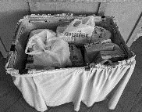
In addition, we continued our support for Global Servants Jon and Amanda Good as they serve with International Ministries. We also supported Ben Hunt, a LOGOS graduate in his ministry with Resource Exchange International and joined with the Worship Committee in honoring our mothers and fathers with a matching love gift collection for Midwest Food Bank.
FBC supported the community Big Give food drive collecting over 300 pounds of non-perishable food items for families to enjoy a traditional Thanksgiving meal; welcomed over 75 children and their families to enjoy decorated car trunks, bubbles, and candy during Trunk n Treat; adopted five single parent families from Sugar Creek Elementary School with food, gifts, and household supplies for Christmas; and continued our partnership with Sugar Creek packing food bags for weekly distribution to students. Various members also volunteered in the school’s classrooms, at PTO events, and family nights.
Big Give Food Drive 2023
We added the Carle BroMenn Compassion Cupboard in July as a partner to collect single serving simple food items for food challenged individuals being discharged from the hospital. We also participated in the McLean County Medical Debt Jubilee by providing start-up funds the board approved from the Fellowship Fund and having a special offering collected in August. We donated over $8,000 and along with the Bloomington/Normal community, over $27,000 was collected which represents more than 2.7 million of medical debt relief for individuals in Illinois!
FBC also held a snack/hot drink/paper good collection for Safe Harbor’s Midnight Café that opened during the cold weather months that provided a warm place to sit up all night and take a warm shower. The small group Koinonia continues to purchase, prepare, and serve a meal once a month at Safe Harbor. ABWM continues to provide financial support for various mission partners and gave prayer shawls to high school graduates.
The month of February the committee highlighted 29 International Ministries Global Servants asking the congregation to pray for them as they continue working around the world bringing the light into a dark world. In March we worked with Family Care and their Meet and Eat ministry by inviting Jon and Amanda Good to share their ministry with Europe.
FBC continues to support the four special offerings with generous donations to America for Christ, One Great Hour of Sharing, International Ministries and Retired Ministers and Missionaries.
As we prepare for the transition of leadership changes within the church, we look forward to continuing our Type-A personality in supporting local, regional, national, and international ministries. The committee is extremely grateful for your generous heart, hands, and financial support.
Respectfully Submitted by
Becky Strack, Chair Committee

2023 -2024 Nominating Committee Annual Report
Committee Members: Al Azinger, Kristi Greenfield, Paul Lawrence, Janie Rempel,
and Al Strauch (Vice Moderator - Chair).
The committee familiarized themselves with the newly approved Manual on Committees document to begin our process. The Manual on Committees document describes the connections of the committee and ministry and service team positions as well as outlines the main responsibilities of those positions. The Nominating Committee used the leadership chart from the Manual on Committees and the FBC Board and Committees Members document as the basis for which positions needed to be filled. The Treasurer, Human Resources (Personnel) and Stewardship (formally a Board position) Chair roles have leaders whose terms continue until May of 2025. These are the positions needing to be filled

- Moderator
- Vice Moderator
- Clerk
- Facilities
- Outreach
- Spiritual Formation
- Worship
- Feeding the Soul
- Sharing the Blessing
- Connecting the Community
- Technology
- Pastoral Relations (2 openings)
The Nominating Committee structured the open positions for a one third rotation of the Church Board when asking people to fill the various leadership spots. The Nominating Committee presents the names to the congregation for approval to serve in the named leadership positions. The list of names and the term they were asked to fill is follows:
Board Positions
- Moderator - Al Strauch 3-year term
- Vice Moderator - Mary Jo Douglass 2-year term
- Clerk - Debbie Stumm 2-year term
- Worship - David Greenfield 2-year term
- Spiritual Formation - Nathan Jennings 1 year term
- Outreach - Becky Strack 3-year term
- Facilities – Sue Strauch 3-year term

Facilitators
- Feeding the Soul - Gretchen Clemmons 3-year term
- Sharing the Blessing - Becky Strack 3-year term
- Connecting the Community - Joyce Benton 3-year term
- Technology - Michelle Wiggins 3-year term
Pastoral Relations
- Daniel Schuetz 3-year term
- Samuel Kambhampati 3-year term
The Committee would like to thank all the leaders who continued their service an extra year during the work of the ad-hoc leadership committee. We would also like to acknowledge and thank all the individuals who are finished with this term.
Mary Jo Douglass
Joyce Benton
Jan Hazekamp
Beverly Jennings
Nathan Jennings
Joan Leitzen
Nick Rude
Becky Strack
Al Strauch
Joyce Topping
Sharon Wetzel
Respectively Submitted, Al Strauch,
Chair of Nominating Committee
2023-2024 Personnel Committee Annual Report
Committee Members: Roger Bridges, Cheryl Gaines, Carissa Haning, Annette Warner, Rich Clemmons, Chair.
FBC Personnel Committee 2023/2024 Annual Report The Personnel Committee primary activities and duties focus is based in three primary areas within the church:
• Review of existing responsibilities of staff positions and determining if any changes are required or needed in each position.
• Review of compensation for each staff position and determine needs for change in compensation.
• Participation in performance reviews with each staff member with the Pastor, in providing support for each staff and input regarding their responsibilities and future needs.
The committee was involved in these responsibilities during the year. FBC Bloomington is blessed with dedicated and committed staff members. We recognize their contributions to our congregation, in sharing their skills in our program areas. In the next year we will continue to look at the needs of staff and the level of support we provide to them. The need to support them financially and spiritually will continue to be our committee goals in the service of First Baptist of Bloomington.
2023-2024 Stewardship Committee Annual Report
Committee Members: Aaron Haning (Chair), Glen Wetzel (Treasurer), Debbie Stumm ( Financial Secretary),
Nobu Tanaka, Greg Topping, Jan Hazekamp
The Stewardship Committee’s primary responsibilities include conducting a Stewardship Campaign and assisting the Church Board in preparing an annual budget.
In our Stewardship Moments, we heard from individuals and organizations who directly serve others, locally, nationally, and internationally, as they shared about their work and expressed their appreciation for First Baptist Church (FBC)’s active involvement and/or our financial support.
As is typical during a Stewardship Campaign, members, and friends of FBC were challenged to consider what we could realistically give financially to further God’s work and ministries at FBC during 2024.
All pledges and historical non-pledged offerings from the campaign were calculated and additional income sources were conservatively projected. We then compared our total projected income to the sum of each church committee’s budget request.
The Church Board voted on and passed the calendar year 2024 budget at the December 14, 2023 Church Board meeting with expected income of approximately $338,000 and expected expenses of approximately $385,000 resulting in an approximate deficit of $47,000. On a positive note, there have been anticipated budget deficits for prior years 2019 through 2023 with income exceeding expenses for each of the years 2019 through 2023.
As we reflect on this past year of ministry, the Stewardship Committee would like to thank:
- Everyone who gave generously via their offerings and/or time
- Melissa Larson for donating the print materials used in the mailings for the Stewardship Campaign,
- All of those that have faithfully collected, summed, and deposited our offerings each week,
- Debbie Stumm for her assistance with the budget preparation.
Respectfully submitted,
Aaron Haning, Stewardship Committee Chair

2023-2024 Trustees Committee Annual Report
Committee Members: Nick Rude (Chair), Rich Clemmons, Mary Jo Douglass, Sharie Huff,
Al Strauch, Rick VanArsdale, and Barry Warner.
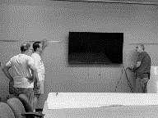
The Facilities Committee works to further the vision and ministry of the congregation by bringing people together in work-related fellowship and by fostering a sense of ownership that everyone may embrace. The trustees work with all other church committees to assist in providing the space and equipment the other committees need to carry out their goals. The trustees also work in conjunction with the custodial campus manager to make the church grounds and facilities a safe and inviting place for worship and other church activities while being good stewards of the money allocated in the budget. This group, along with other volunteers, strives to maintain our church as an open and inviting place not only for our own functions, but also for community activities.
FBC Workday
Major accomplishments this past year include:
- Painted lettering on the lighted brick sign on College Ave. to make it more visible
- Purchased a portable fire pit, created an area for use, and created rules for use of the firepit
- Instituted one workday each quarter
- Replaced several emergency lights and exit lights
- Cut and removed low hanging trees (in addition to major tree
removal work)
- Began converting 5 acres of land to a Pollinator Habitat. This project will take about 3 years to establish the plot.
- Received grants from Illinois Prairie Community Foundation and Pheasants Forever to help with the Pollinator Habitat.
- Contracted to remove several trees that were dead or dying
- Hung TVs and white boards in classrooms
- Had several pews recovered by Paul’s Upholstery
- Updated cleaning expectations for the building
- Lubricated the front door to make it easier to open
- Completed 5-year inspection with Pipco
- Made a chart for Capital projects, estimated costs, and developed timelines for the next 10 years
- Assisted in running tech cables throughout the building
- Shampooed carpet in the sanctuary
Goals for the coming year include resealing the parking lot, repairing, or replacing thermostats, continuing to remove dead, or dying landscape, and continuing to work on the Pollinator Habitat.
The Trustees would like to thank the many dedicated non-committee members who cheerfully volunteer their time and talents to help complete essential tasks while expecting no recognition for their work.
Respectfully Submitted, Nick Rude
Facilities Committee Chair

2023-2024 Worship Committee Annual Report
Committee Members: Joyce Benton; Committee Chair, Wendi Ayers, Esther Harrison,
Jay Hartzler Chrissy Jennings, Sarah Tomkinson,
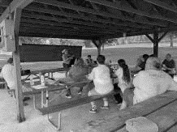
The worship committee coordinates with the worship staff at First Baptist to offer meaningful worship experiences to all who come to Sunday morning worship, Wednesday Night Vespers and special holiday services and events.
The committee collaborates with the worship staff and thank them for being so dedicated to having a genuine desire to provide something for everyone in each service. So much goes on behind the scenes with the leadership and work Pastor Brian provides the team.
We thank Michelle Wiggins for her work at providing accurate announcements on the screen, photos, song lyrics and more. Our music staff also includes Diane Russell with beautiful playing of the organ and piano, plus leads the Bell choir. The praise team, led by Allison Benton, brings more inspirational and meaningful music to help our
church reach all ages. And Sharon Huff brings much excitement and passion to leading the choir.
Vespers Service at the Park
The worship committee also wants to thank the dedicated weekly volunteers from the members of the band and vocalists and the tech team who manage our sound, song lyric slides at both Sunday morning and Wednesday vespers services. And lastly the video live stream people which includes 2-3 camera men depending on the service and the person managing the live stream on Sunday morning and a couple of holiday services in the choir room. David Greenfield and Michelle Wiggins have developed many youths to be a part of this as well as other adults.
The committee is also grateful for the volunteers who help the LOGOS Worship arts. The students have the opportunity to learn new skills in worshipping and sharing their gifts to God. They had opportunities to share those gifts at both Sunday morning and Wednesday night vespers services. The Children’s church youth also offered worship offering during several services throughout the year.
During the summer of 2023, we had 6 individuals offer their faith/testimonies during worship. We had 4 outdoor services with 2
of them having potluck luncheon afterwards. The summer-Live stream was offered at the church in the Pathfinders class as well. The vespers service had two off site events including a service and cookout at Underwood park and a gathering at uptown circle in downtown Normal for fellowship and listen to music.
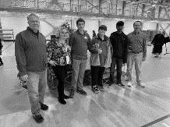
As the fall approached, the committee planned World Communion Sunday, All Saints Sunday and began working with LOGOS staff on how to incorporate LOGOS children in worship.
Mission moments were added to worship on a more regular basis. Children’s moments were added into worship more often. We celebrated the “Debt Jubilee”.
Fall Vespers service theme was “Finding God in the Depths”. We find those who volunteer to speak on these topics to be courageous and honest. Giving others the opportunity to do the same in the small groups.
The FBC Tech team offered their services to the Community Thanksgiving service at the YMCA this year. Advent approached with a busy season as usual. The choir was challenged to sing a couple of songs from the Messiah and with a few extra singers provided great inspiration to all who were there to listen.
FBC Tech Team at
Interfaith Thanksgiving Service
We also had 2 other songs from the Messiah as a solo and duet during the advent season. A big thank you to the LOGOS teams both adults and youth for lighting the advent candles.
As 2024 began, Wednesday night vespers utilized a video series and discussion questions. Lent began with Ash Wednesday on Valentine’s day with beaded bracelet’s handed out to those attending representing the Love of God.
We had two Sundays with pulpit supply while Pastor Brian was on vacation. Feb. 25th Rob Kirbach in person and March 3rd Ben Hunt on video.
Holy Week began Palm Sunday March 24th with the children bringing in the palms. Maundy Thursday included communion and readings from Psalms, Matthew, and Mark. Good Friday was an Ecumenical Service and held at First Presbyterian. Some choir members participated in the combined choir. Easter was on March 31st with breakfast, egg hunt for the children and worship.
Respectfully Submitted
Joyce Benton, Chair Committee

2023-2024 American Baptist Women Ministries Annual Report
Committee Members: Joan Leitzen (Circle Chair, Special Interest Ministries), Gabrielle Hastings (Prayer Shawl Ministry), Bea Olson (Love Gift), Joyce Topping (Secretary, White Cross), Sandra Yeager (Treasurer)
Our new theme is to “Be Strong, Be Courageous” as we walk shoulder to shoulder, we are connected heart to heart in Gods call on this ministry to lift women and in doing so we lift our denomination. We continue to seek wholeness, divine discernment to “Let the Walls Fall Down” removing all spiritual , emotional, and physical walls, wow we not be afraid or discouraged for the Lord our God is with us, wherever we go.
Special Interest Missionaries International Ministries
- Revs. Taku & Katie Longkumer, East and South Asia
- Jae Stockton. Mexicali, Baja California, México
- Dr. Timothy & Kathleen Rice, Democratic Republic of Congo
Funding
- Love Gift $721
- ABWM Region project – Blackhawk Camp $300
- ABWM Area III project ( Friendship House and One Hope United) $200
- Sally peck Student Aid Fund $200
- National Support $100
- Regional Support $100
- AREA Support $50
- Women’s & Girls Missions fund $50
- Refit fund $25
- 5 Christmas gifts (gifts to Global Servants @$30 each) $150
TOTAL $1896
Spring rally will be held April 20, 2024 in Pontiac. Speaker- “A visit with Corrie Ten Boom” featuring Gayle Haas The Fall rally is still in its planning stage.
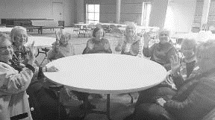
Respectfully Submitted by
Joan Leitzen, American Baptist Women’s Ministry President
American Baptist Women’s Ministry Monthly Meeting

